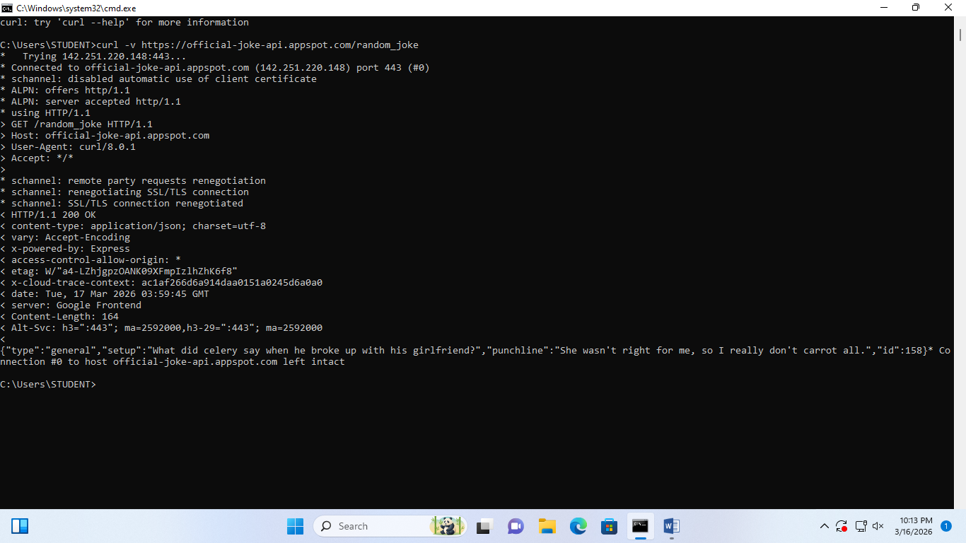

QUESTIONS:
A: Identify the Method used in the output.
-The Method used is GET
This method retrieves data from the API endpoint.
B: Identify one Header returned by the server(e.g, content-type).
-One header returned by the server is:
Content-Type: Application/json
This header indicates the format of the data returned by the API.
C: What format is Payload(the actual joke data)returned in?
-The payload is returned in JSON(JavaScript Object Notation)format.
JSON is commonly used in APIs because it is easy for systems to read and process.

